**Câu 1:  
bài 1:  
code:  
#include <REGX51.H>**

**char so[]={0x40,0x79,0x24,0x30,0x19,0x12,0x02,0x78,0x00,0x10, 0x89,0x06,0xC7,0x40};**

**//**

**#define led1 P2_0**

**#define led2 P2_1**

**#define sang 0**

**#define tat 1**

**char i;**

**void delay(int time){**

**while(time--);**

**}**

**void main(){**

**led1 = led2 = tat;**

**while(1){**

**led1 = sang;**

**P0 = so[0];**

**delay(300000);**

**led1 = tat;**

**led2 = tat;**

**P0 = so[0];**

**delay(300000);**

**led2 = sang;**

**}**

**}**

**Mô phỏng proteus:**

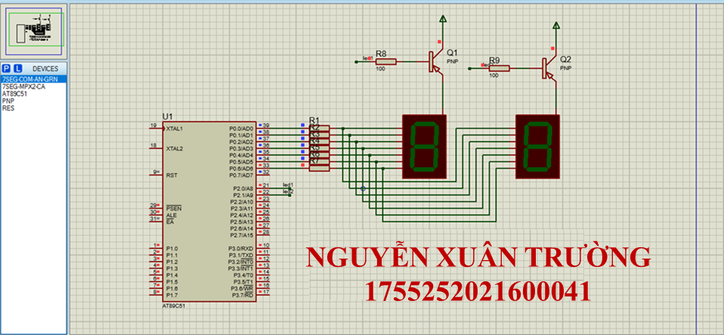

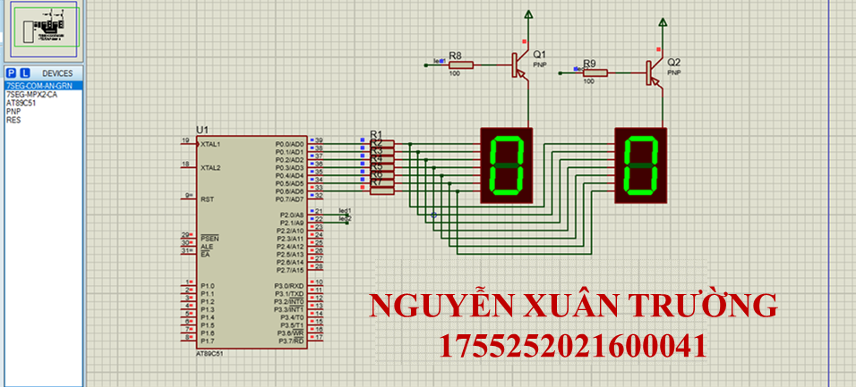

**Bài 2:  
  
code:  
xuantruong:  
#include <REGX51.H>**

**char so[]={0x40,0x79,0x24,0x30,0x19,0x12,0x02,0x78,0x00,0x10, 0x89,0x06,0xC7,0x40};**

**//**

**char i;**

**int dem;**

**unsigned chuc, donVi;**

**#define led1 P2_0**

**#define led2 P2_1**

**#define sang 0**

**#define tat 1**

**void delay(int time){**

**while(time--);**

**}**

**void main(){**

**led1 = led2 = tat;**

**while(1){**

**for (dem=0;dem<40;dem++){**

**//tach chu so**

**chuc = dem/10;**

**donVi = dem%10;**

**for (i = 0 ; i<=10;i++){**

**led1 = sang;**

**P0 = so[chuc];**

**delay(1000);**

**led1 = tat;**

**led2 = sang;**

**P0 = so[donVi];**

**delay(1000);**

**led2 = tat;**

**}**

**}**

**}**

**}**

**Mô phỏng proteus:  
  
  
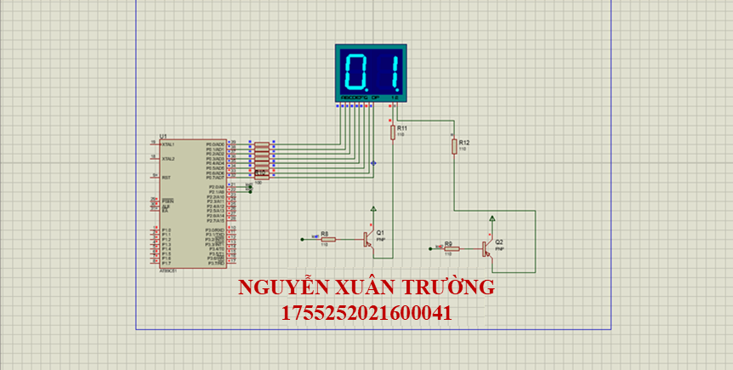**

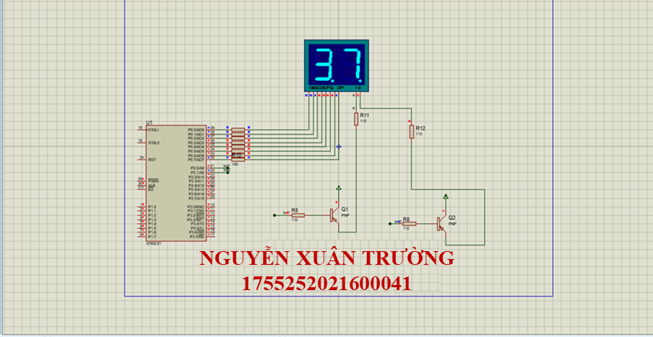

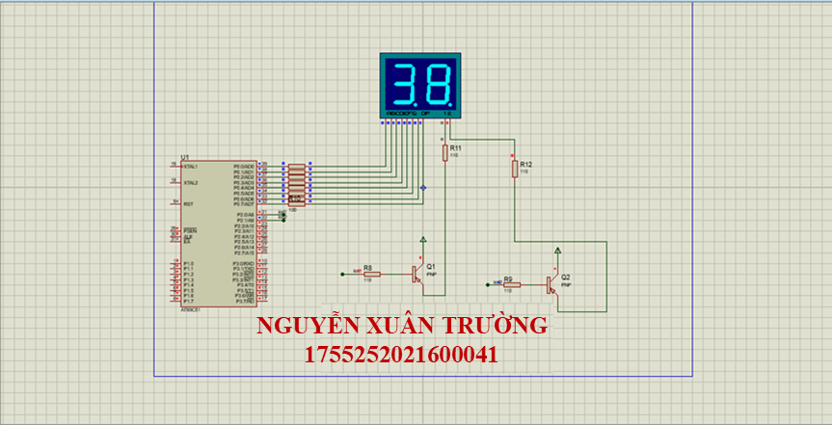

**CÂU 2:**

**Bài 1:**

**Code:**

**#include <REGX52.H>**

**void delay_ms(int ms){**

**while(ms--){**

**TH0 = 0Xfc;**

**TL0 = 0x18;**

**TR0 = 1;**

**while(!TF0);**

**TF0 = 0;**

**TR0 = 0;**

**}**

**}**

**void main(){**

**EX0 = 1; //cho phep ngat ngoai 0**

**IT0 = 1; //chon kieu ngat theo suon**

**EA = 1; //cho phep ngat ngoai cuc**

**while(1){**

**P2 = 0;**

**delay_ms(1000);**

**P2 = 0xff;**

**delay_ms(1000);**

**}**

**}**

**void ngat() interrupt 0{**

**long a = 50000;**

**P1_3 = 0;**

**while(a--){};**

**P1_3 = 1;**

**}**

**Mô phỏng :**

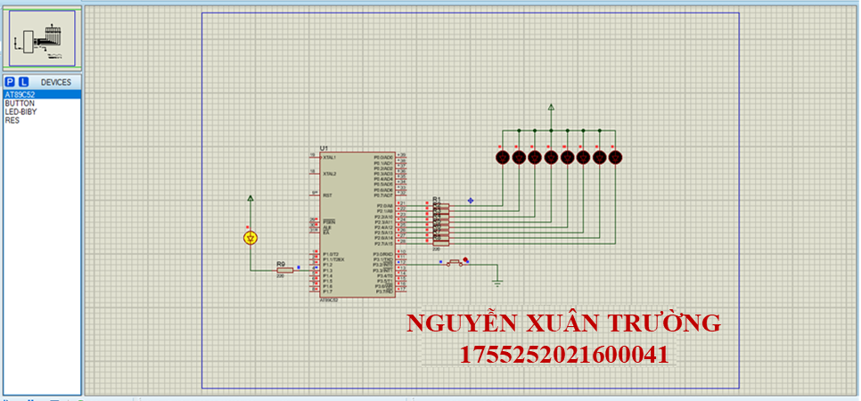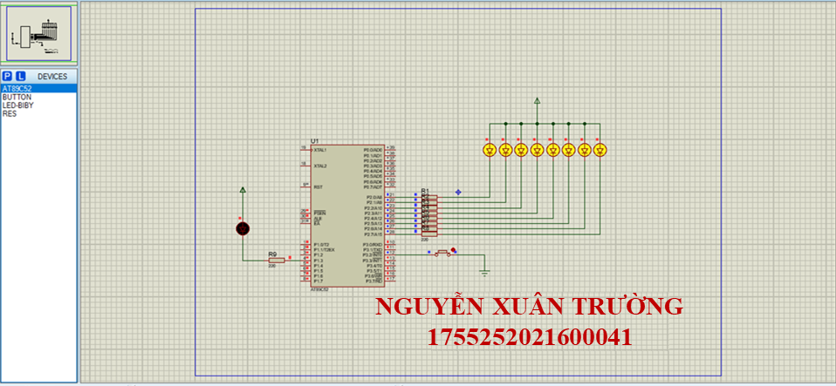

**Bài 2:**

**Code:**

**#include <REGX52.H>**

**#define led1 P3_0**

**#define led2 P3_1**

**#define sang 0**

**#define tat 1**

**sbit up=P3^2;**

**char so[ ]={0x40,0x79,0x24,0x30,0x19,0x12,0x02,0x78,0x00,0x10};**

**char count;**

**unsigned char chuc,donvi;**

**void delay_ms(int time){**

**while(time--){**

**TMOD=0x01;**

**TH0=0xfc;**

**TL0=0x18;**

**TR0=1;**

**while(!TF0);**

**TF0=0;**

**TR0=0;**

**}**

**}**

**void tang()interrupt 0{**

**count++;**

**if(count>30) count=0;**

**}**

**void main (){**

**EA=1;**

**EX0=1;**

**IT0=1;**

**EX1=1;**

**IT1=1;**

**while(1){**

**chuc=count/10;**

**donvi=count%10;**

**led1 =sang; P2=so[chuc]; delay_ms(10); led1 =tat;**

**led2 =sang; P2=so[donvi]; delay_ms(10); led2 =tat;**

**}**

**}**

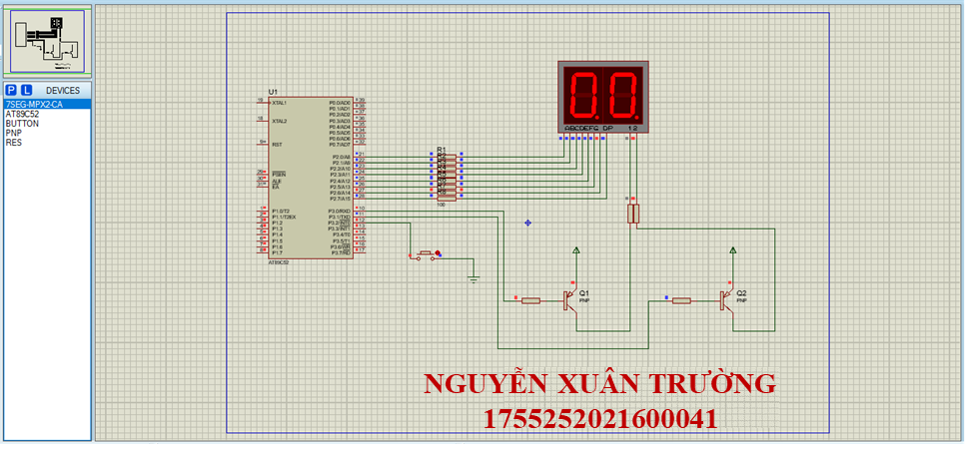**Mô phỏng:**

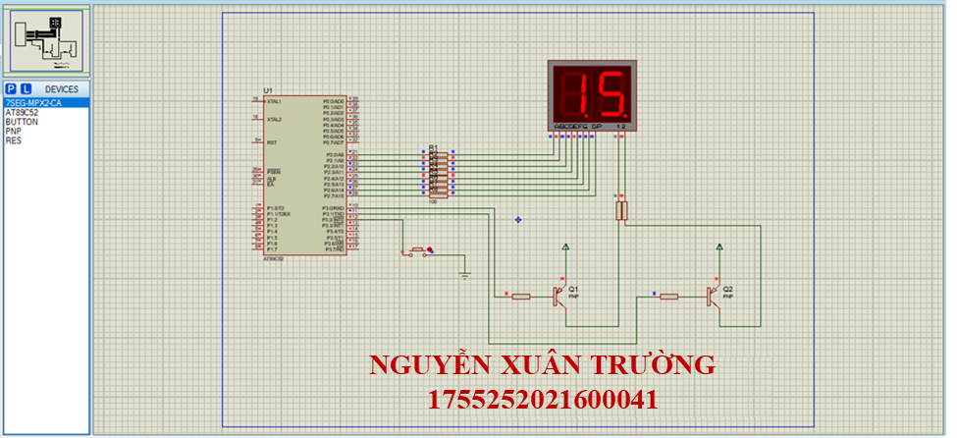

**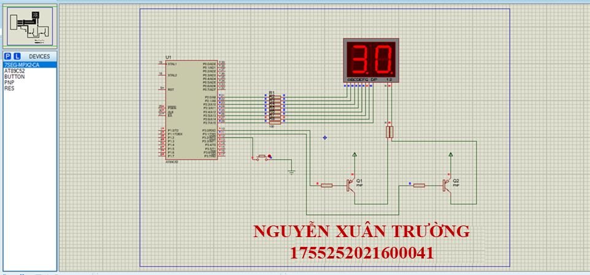  
  
CÂU 3:**

**Bài 1: Hiển thị tên LCD:**

**code:**

**#include <REGX52.H>**

**#define LCD_RS P1_0**

**#define LCD_RW P1_1**

**#define LCD_EN P1_2**

**#define LCD_D4 P0_4**

**#define LCD_D5 P0_5**

**#define LCD_D6 P0_6**

**#define LCD_D7 P0_7**

**void delay_us(unsigned int t){**

**unsigned int i;**

**for(i=0;i<t;i++);**

**}**

**void delay_ms(unsigned int t){**

**unsigned int i,j;**

**for(i=0;i<t;i++)**

**for(j=0;j<125;j++);**

**}**

**void delay(long time)**

**{**

**while (time--);**

**}**

**void LCD_Enable(void){**

**LCD_EN =1;**

**delay_us(3);**

**LCD_EN =0;**

**delay_us(50);**

**}**

**void LCD_Send4Bit(unsigned char Data){**

**LCD_D4=Data & 0x01;**

**LCD_D5=(Data>>1)&1;**

**LCD_D6=(Data>>2)&1;**

**LCD_D7=(Data>>3)&1;**

**}**

**void LCD_SendCommand(unsigned char command){**

**LCD_Send4Bit(command >>4);**

**LCD_Enable();**

**LCD_Send4Bit(command);**

**LCD_Enable();**

**}**

**void LCD_Clear(){**

**LCD_SendCommand(0x01);**

**delay_us(10);**

**}**

**void LCD_Init(){**

**LCD_Send4Bit(0x00);**

**delay_ms(20);**

**LCD_RS=0;**

**LCD_RW=0;**

**LCD_Send4Bit(0x03);**

**LCD_Enable();**

**delay_ms(5);**

**LCD_Enable();**

**delay_us(100);**

**LCD_Enable();**

**LCD_Send4Bit(0x02);**

**LCD_Enable();**

**LCD_SendCommand(0x28);**

**LCD_SendCommand(0x0c);**

**LCD_SendCommand(0x06);**

**LCD_SendCommand(0x01);**

**}**

**void LCD_Gotoxy(unsigned char x, unsigned char y){**

**unsigned char address;**

**if(!y)address=(0x80+x);**

**else address= (0xc0+x);**

**delay_us(1000);**

**LCD_SendCommand(address);**

**delay_us(50);**

**}**

**void LCD_PutChar(unsigned char Data){**

**LCD_RS=1;**

**LCD_SendCommand(Data);**

**LCD_RS=0;**

**}**

**void LCD_Puts(char*s){**

**while (*s){**

**LCD_PutChar(*s);**

**s++;**

**}**

**}**

**void main(){**

**LCD_Init();**

**LCD_Puts(" hello");**

**delay_ms(1000);**

**LCD_Clear();**

**LCD_Gotoxy(0,0);**

**LCD_Puts("trinh van khanh");**

**delay_ms(1000);**

**LCD_Gotoxy(0,1);**

**LCD_Puts("1755252021600019");**

**while(1);**

**}**

**Mô phỏng:**

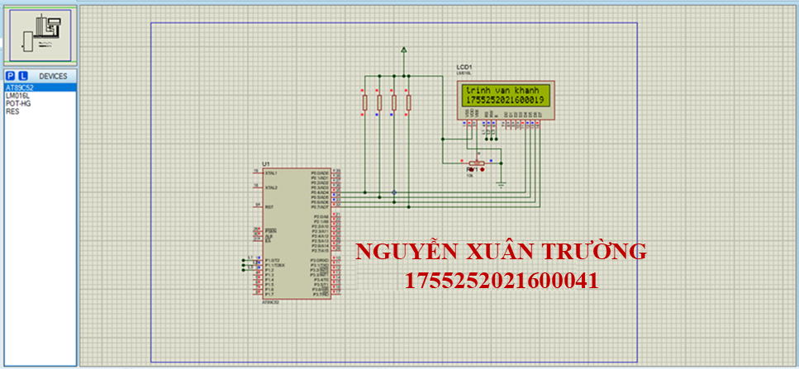

**CÂU 4:**

**CODE:**

**#include <REGX52.H>**

**#include <RTX51TNY.H> //Su dung thu vien RTX51 Tiny Real-Time**

**#define INIT 0 //Dinh nghia INIT = 0**

**#define DO 1 //Dinh nghia DO = 1**

**#define BUTT 2 //Dinh nghia BUTTTON = 2**

**sbit LED_DO = P1^2; //Dinh nghia chan LED_DO**

**sbit BUTTON = P1^3; //Dinh nghia chan BUTTON**

**void USART(void) interrupt 4 //Ngat nhan USART**

**{**

**if(RI) //Flag nhan duoc ki tu**

**{ //Clear flag**

**RI=0; //Nhan ki tu**

**isr_send_signal(DO); //Gui signal cho task DO**

**}**

**}**

**//=========Ham Start up==========**

**void Startup(void) _task_ INIT**

**{**

**SCON=0x52; //USART che do 1**

**TMOD=0x21; //Timer 1 mode 2**

**TH1=TL1=-3; //baudrate 9600**

**TR1=1;**

**IE=0x90; //Ngat USART**

**os_create_task (DO); //Tao Task_Led_Do**

**os_create_task (BUTT); //Tao Task BUTTON**

**os_delete_task (INIT); //Xoa Task hien tai (Task 0)**

**}**

**void Task_Led_Do(void) _task_ DO**

**{**

**while(1)**

**{**

**os_wait2(K_SIG ,50); //Cho signal voi time out 50 ticks**

**LED_DO ^= 1; //Dao trang thai Led Do**

**}**

**}**

**void Task_BUTTON(void) _task_ BUTT**

**{**

**while(1)**

**{**

**if(BUTTON == 0) //Nhan nut nhan = 0**

**{**

**os_send_signal(DO); //Gui signal cho task DO**

**while(BUTTON==0); //Cho nut nhan = 1(Chong nhieu)**

**}**

**os_wait2(K_TMO, 10); //Cho 10 ticks = 100ms**

**}**

**}**

**MÔ PHỎNG:**

